Name: Muhammad Mufeez

Roll No: 23k-0800

Section: J

LAB 04

Question #1

**CODE:**

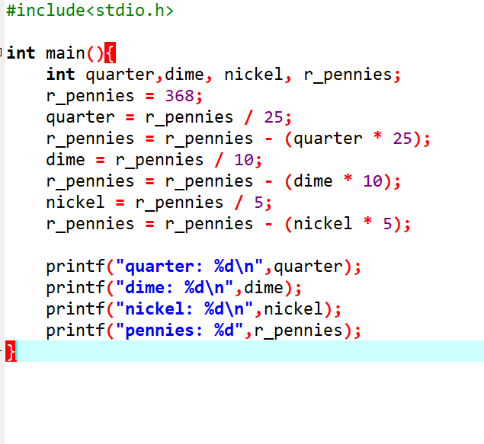

**OUTPUT:**

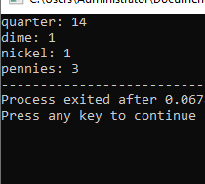

Question #2  
**CODE:**

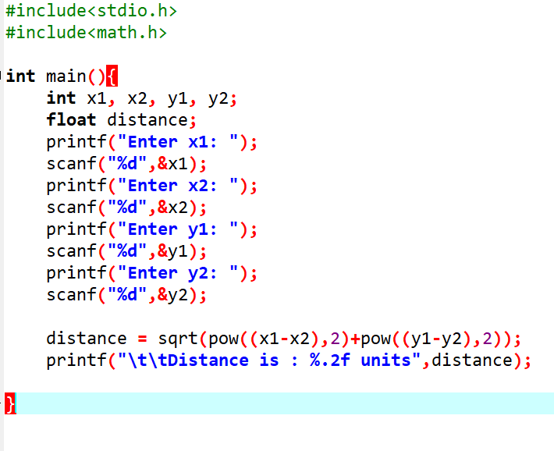

**OUTPUT:**

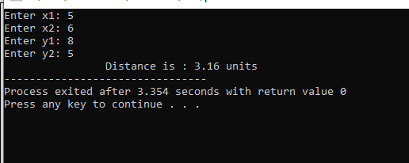

Question #3

**CODE:**

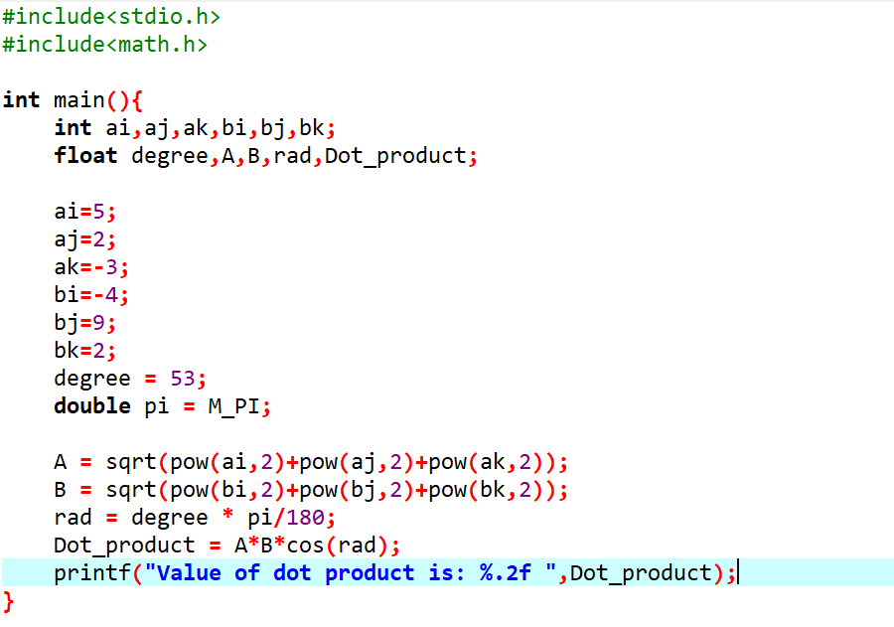

**OUTPUT:**

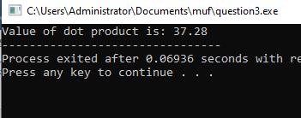

Question #4

**CODE:**

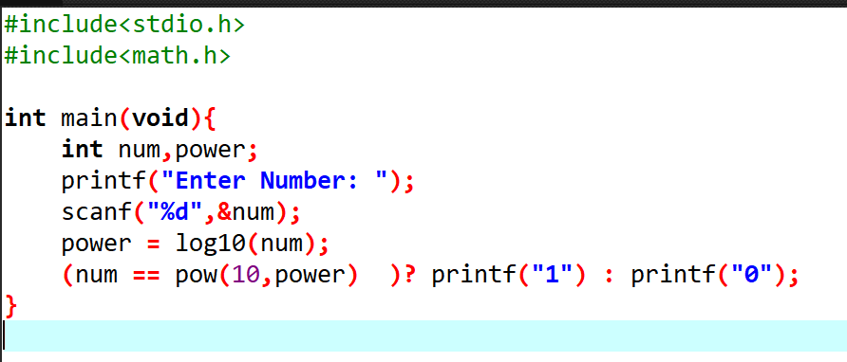

**OUTPUT:**

Question #5  
**CODE:**

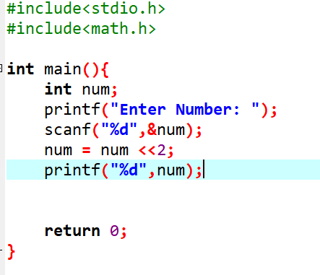

**OUTPUT:**

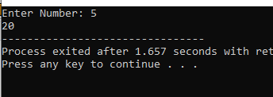

Question #6  
**CODE:**

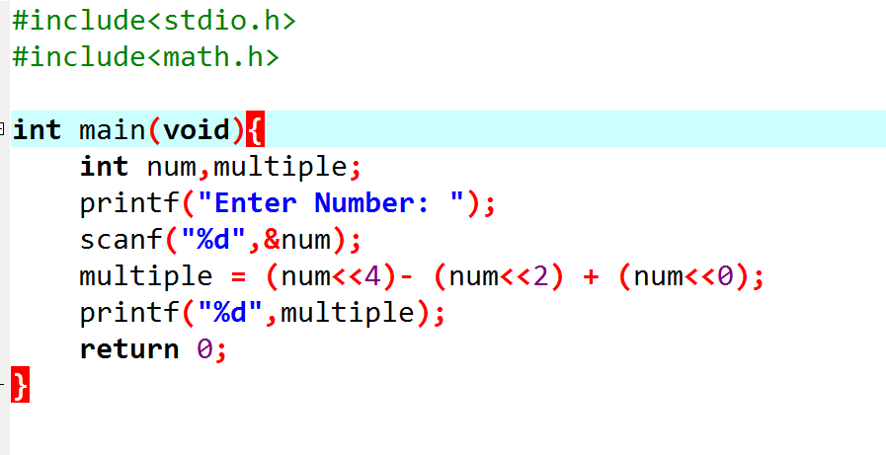

**OUTPUT:**

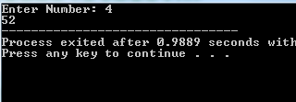

Question #7  
**CODE:**

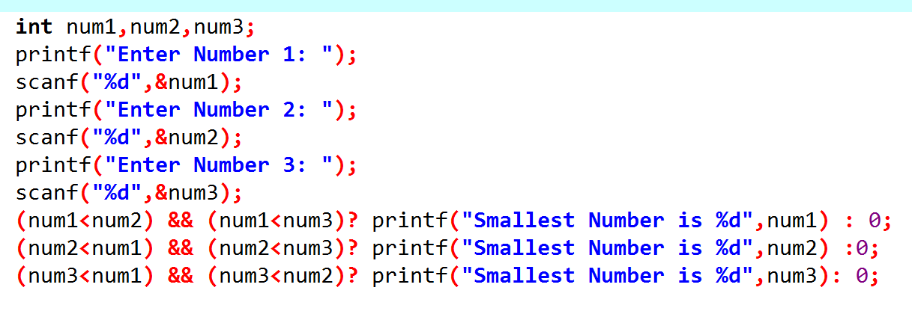

**OUTPUT:**

